1. Write command to list all the links from a directory?
In this UNIX command interview questions interviewer is generally checking whether user knows basic use of "ls" "grep" and regular expression etc. You can write command like:
ls -lrt | grep "^l"

2. Create a read-only file in your home directory?
This is a simple UNIX command interview questions where you need to create a file and change its parameter to read-only by using chmod command you can also change your umask to create read only file.
$ touch file
$ chmod 400 file
Read more about file and directory permission in unix and linux here.
3. How will you find which operating system your system is running on in UNIX?
By using command "uname -a" in UNIX

4. How will you run a process in background? How will you bring that into foreground and how will you kill that process?
For running a process in background use "&" in command line. For bringing it back in foreground use command "fg jobid" and for getting job id you use command jobs, for killing that process find PID and use kill -9 PID command. This is indeed a good Unix Command interview questions because many of programmer not familiar with background process in UNIX.

5. How do you know if a remote host is alive or not?
You can check these by using either ping or telnet command in UNIX. This question is most asked in various Unix command Interview because its most basic networking test anybody wants to do it.

6. How do you see command line history in UNIX?
Very useful indeed, use history command along with grep command in UNIX to find any relevant command you have already executed. Purpose of this Unix Command Interview Questions is probably to check how familiar candidate is from available tools in UNIX operation system.

7. How do you copy file from one host to other?
Many options but you can say by using "scp" command. You can also use rsync command to answer this UNIX interview question or even sftp would be ok.

8. How do you find which process is taking how much CPU?
By using "top" command in UNIX, there could be multiple follow-up UNIX command interview questions based upon response of this because “TOP” command has various interactive options to sort result based upon various parameter.

9. How do you check how much space left in current drive ?
By using "df" command in UNIX. For example "df -h ." will list how full your current drive is. This is part of anyone day to day activity so I think this Unix Interview question will be to check anyone who claims to working in UNIX but not really working on it.

10. What is the difference between Swapping and Paging?
Swapping:
Whole process is moved from the swap device to the main memory for execution. Process size must be less than or equal to the available main memory. It is easier to implementation and overhead to the system. Swapping systems does not handle the memory more flexibly as compared to the paging systems.
Paging:
Only the required memory pages are moved to main memory from the swap device for execution. Process size does not matter. Gives the concept of the virtual memory. It provides greater flexibility in mapping the virtual address space into the physical memory of the machine. Allows more number of processes to fit in the main memory simultaneously. Allows the greater process size than the available physical memory. Demand paging systems handle the memory more flexibly.

Intermediate UNIX Interview Questions Answers
1. What is difference between ps -ef and ps -auxwww?
This is indeed a good Unix Interview Command Question and I have faced this issue while ago where one culprit process was not visible by execute ps –ef command and we are wondering which process is holding the file.
ps -ef will omit process with very long command line while ps -auxwww will list those process as well.

2. How do you find how many cpu are in your system and there details?
By looking into file /etc/cpuinfo for example you can use below command:
cat /proc/cpuinfo

3. What is difference between HardLink and SoftLink in UNIX?
I have discussed this Unix Command Interview questions in my blog post difference between Soft link and Hard link in Unix

4. What is Zombie process in UNIX? How do you find Zombie process in UNIX?
When a program forks and the child finishes before the parent, the kernel still keeps some of its information about the child in case the parent might need it - for example, the parent may need to check the child's exit status. To be able to get this information, the parent calls 'wait()'; In the interval between the child terminating and the parent calling 'wait()', the child is said to be a 'zombie' (If you do 'ps', the child will have a 'Z' in its status field to indicate this.)
Zombie : The process is dead but have not been removed from the process table.

5. What is "chmod" command? What do you understand by this line “r-- -w- --x?
chmod command is used to change permission of a file or directory in UNIX. The line you see shows the permission for three different set of people : user, group and others. User is the currently logged in user, while group is for all other member which are part of certain group and others means anyone other than user and group member. Each group has three permissions rwx stands for read, write and execute and they are written as user_group_others. So in above line, user has only read permission, group members has write permissions and other people has only execute permission. If it is a directory then you need execute permission to go inside that directory. See here for more detailed answer.
6. There is a file some where in your system which contains word "UnixCommandInterviewQuestions” How will find that file in Unix?
By using find command in UNIX for details see here 10 example of using find command in Unix

7. In a file word UNIX is appearing many times? How will you count number?
grep -c "Unix" filename

8. How do you set environment variable which will be accessible form sub shell?
By using export command, for example export count=1 will be available on all sub shell.

9. How do you check if a particular process is listening on a particular port on remote host?
By using telnet command for example “telnet hostname port”, if it able to successfully connect then some process is listening on that port. To read more about telnet read networking command in UNIX

10. How do you find whether your system is 32 bit or 64 bit ?
Either by using "uname -a" command or by using "arch" command.

Advanced UNIX Interview Questions and Answers
1. How do you find which processes are using a particular file?
By using lsof command in UNIX. It wills list down PID of all the process which is using a particular file.

2. How do you find which remote hosts are connecting to your host on a particular port say 10123?
By using netstat command execute netstat -a | grep "port" and it will list the entire host which is connected to this host on port 10123.

3. What is nohup in UNIX?
nohup is a special command which is used to run process in background, but it is slightly different than & which is normally used for putting a process in background. An UNIX process started with nohup will not stop even if the user who has stared log off from system. While background process started with & will stop as soon as user logoff.

4. What is ephemeral port in UNIX?
Ephemeral ports are port used by Operating system for client sockets. There is a specific range on which OS can open any port specified by ephemeral port range.

5. If one process is inserting data into your MySQL database? How will you check how many rows inserted into every second?
Purpose of this Unix Command Interview is asking about watch command in UNIX which is repeatedly execute command provided with specified delay.

6. There is a file Unix_Test.txt which contains words Unix, how will you replace all Unix to UNIX?
You can answer this Unix Command Interview question by using SED command in UNIX for example you can execute following command to replace all Unix word to UNIX
sed s/Unix/UNIX/g fileName

7. You have a tab separated file which contains Name, Address and Phone Number, list down all Phone Number without there name and Addresses?
To answer this Unix Command Interview question you can either you AWK or CUT command here. CUT use tab as default separator so you can use
cut -f3 filename

8. Your application home directory is full? How will you find which directory is taking how much space?
By using disk usage (DU) command in Unix for example du –sh . | grep G will list down all the directory which has GIGS in Size.

9. How do you find for how many days your Server is up?
By using uptime command in UNIX

10. You have an IP address in your network how will you find hostname and vice versa?
This is a standard UNIX command interview question asked by everybody and I guess everybody knows its answer as well. By using nslookup command in UNIX
s
1. Command to find out those files which are hidden in the current directory
Answer:
$ ls -lrta
2. Command to find out existing active running process currently in the UNIX system?
Answer:
$ ps -ef
Now if we know the name of the process we can add grep after ps –ef like below:
$ ps –ef | grep java
Let us move to the next UNIX interview questions
3. How one can determine memory utilization by an entire process in UNIX box?
Answer:
This is the basic UNIX interview questions that are asked in an interview.
By using the $ top command.
top command provides all the details including memory usage, process ID, and others. Commands display should be like below: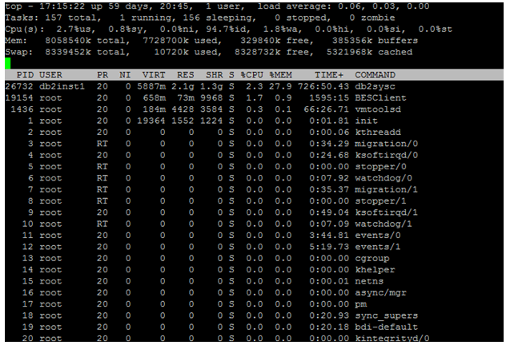
4. Explain command to find out Exception in application log file, suppose log file name is server.log?
Answer:
$ grep ‘Exception’ server.log —> will give the expected result.
$ grep ‘Exception’ server.log | wc –l —> will give the proper count of exception in total application server log file.
5. Command to find all the files exist in the same directory or subdirectory which contains a name like ‘Java’?
Answer:
$ find. -name ‘Java’

Part 2 – UNIX interview questions and answers (Advanced)
This first part covers Advanced UNIX interview questions and answers
6. How is Shell script accepting command line arguments for internal processing in shell script logic?
Answer:
Arguments pass from the command line can be easily accepted in the shell script by using $ (dollar sign). It always followed argument numeric position on a command line.
7. Display or present last 200 lines of an existing file in UNIX box.
Answer:
$ tail -200f newfile.txt
Let us move to the next UNIX interview questions
8. Command to find out remaining disk space in UNIX/Linux server.
Answer:
$ df –kl
[db2inst1@eproc-db1-eps-temp ~]$ df -kl
Filesystem 1K-blocks Used Available Use% Mounted on
/dev/mapper/vg0-root 41153856 6322928 32733776 17% /
tmpfs 4029268 100 4029168 1% /dev/shm
/dev/sda1 487652 33803 428249 8% /boot
/dev/mapper/vg0-database1
20511356 6900920 12561988 36% /database1
/dev/mapper/vg0-database2
10190136 4346232 5319616 45% /database2
/dev/mapper/vg0-database3
10190136 7615792 2050056 79% /database3
/dev/mapper/vg0-backup
5029504 3549988 1217372 75% /backup
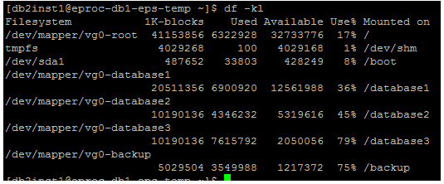
9. Provide access to any script file for executable.
Answer:
$ chmod 755 *.sh
This is the advanced UNIX interview questions that are asked in an interview. If the requirement is to script should be readable, writable and executable for any user, then the command can be chmod 777 *.sh
10. How can we able to kill one process in UNIX box?
Answer:
$ kill -9 #pid —> pid can be found by executing ps –ef

